Chapter 2 Through to the Tableland

Timber cutting, in those early days, was rapaciously selective as our pioneers searched coastal forests solely for the treasure of 'Red Gold'. From the time of Governor Phillip and the first fleet, coastal forests in the Illawarra south of Botany Bay, provided abundant supplies of this marvellous timber, red cedar, useful for every project from building boats to bungalow doors. With progress and prosperity, colonial buildings became more substantial, and the deep rich red finish was prized for turning and furniture. Cedar's strength, lightness, and workability were prized for being worked into elaborate fittings. As well it provided frames for windows and doors. Cedar was the timber of choice for the Government House, built at Parramatta in 1890. By the turn of the century, settlement was leaping north past the Hawkesbury and Broken Bay as valuable coal deposits were exploited around Coal Town, later known as Newcastle. Cutters were lured north to the semitropical rain forests around the Hunter as well as the Paterson River, then known as the Cedar Arm.
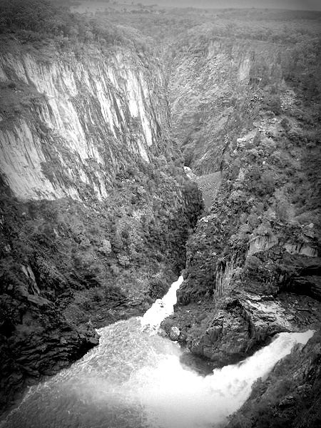
During the first forty years of the new century cedar cutters, mostly convict gangs, were at the leading edge of settlement north, advancing from river to river on up the coast. Cutting gangs at first sought cedars conveniently close to waterways. The lightweight giants were initially felled into local streams for floating to the mouth where coastal shipping could transport the sawn logs to market in the growing colony around Sydney Town. Walking the coastal beaches provided a foot trail highway of rare beauty used by local aboriginals for millennia. 'Whilst there was no beaten track, the aboriginals travelled north from Port Macquarie by following the coast along a succession of sandy beaches, extending to Point Plomer, from thence to Crescent Head.' As already mentioned, several possible routes to the tableland were opening up by land and sea, or by some combination of both.
A view of the country from a peak just north of Algommera Creek, a tributary of Nambucca River, is vividly described by Hodgkinson in his 1842 survey. 'We had a beautiful view from the summit we were now upon. To the westward, amidst a confused mass of mountains rising beyond mountains, covered with universal forest, the eye could trace the deep, narrow valleys full of brush, of the streams forming the Nambucca, curling into the deep mountain recesses. Looking towards the north-west, the direction in which I wished to proceed, tier beyond tier of mountains rose in serrated ridges of steep, high conical summits; the view in that direction being bounded by the dim, blue outline of a level crested range of surpassing altitude. Looking east, the eye embraced the dense forest and swamps on the Nambucca River, the silvery glare of its tranquil reaches, and the blue surface of the boundless Pacific Ocean, which was about twenty-five miles distant. To the south-east, the isolated position of Mount Yarra-Hapinni made it stand forth in bold relief'.
This all but impenetrable coastal jungle was gradually opened up along the numerous streams tumbling eastward out of the mountains. Bridle trails to the tableland followed aboriginal trails and song lines, often blazed by ancient carvings on the mightiest cedars. Sometimes locals led sawyers to the prized Red Gold, but usually to the tree of a rival. Not all arrangements went so amicably for some clans resisted the rapine of their land and the ravish of their women. Pitched battles between cutters and clans were waged, and it would be an understatement to say that mistakes were made.
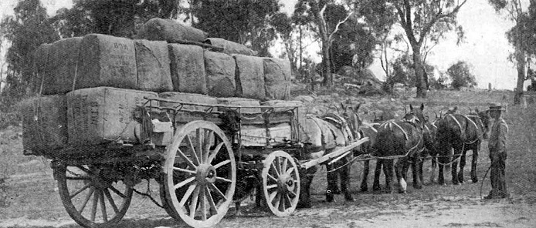
Dwyer's loop on the Nambucca River and Argent's Hill near what came to be Bowraville were whispered about as scenes of orchestrated massacres of the Barengarie and the Dodi clans. Yarrahapini, the Koala home, was a mountain sacred to the Barengarie whose traditional lands extended into the hinterland as far as the eye could see and on up into the escarpment leading to the New England Tablelands. White settlement from the tablelands did not penetrate east towards the coast until cutters were shown the way along aboriginal trails and song lines. Clement Hodgkinson, on Government survey, was shown the trails by aboriginals from around Tailor's Arm behind present day Macksville. Trails like the one up over Horseshoe Mountain, to this day known to the aboriginals as Mistake Mistake Mountain, opened up bridle trails leading down from the Tableland through the coastal forests to the Tasman Sea.
The Wool Road from New England to Port Macquarie was completed about 1840 after being under construction for nearly ten years by convict gangs. On 8 Feb 1840, The Australian newspaper reported on the conclusion of the survey of the last section. It predicted that the road link from New England to the mid-north coast would mean: 'That the hazardous transmission of the wool from the country as well as of Liverpool Plains by the present circuitous and toilsome journey to Maitland will be avoided.' It took a further two years before the Wool Road carried its first fleece to the port for shipping to market in Sydney. On 11 Mar 1842, the Port Macquarie correspondent of The Australian reported: ‘the first arrival of the 'Golden Fleece' from the tableland. Yesterday evening two drays with 16 bales of wool from 'Kentucky', Major Innes's chief station at New England, arrived in town.'
Later in the 40's timber getters cut a track via Mann River from Glen Innes to Grafton on the Clarence, known then as Big River. This track opened up a route for the cutters to travel down from the tableland into the coastal forests to cull Red Gold in the upper reaches of the Clarence River system. A score or so years later the track was upgraded to become The Grafton Road. In the 70's I clearly remember Cobb & Co coaches running a weekly mail service along the road carrying mail that used to be carried on a pony by me as a fifteen-year-old Postal rider.
When I was all of ten years old, we lived for a time on the Uralla gold fields. In the local Aniwan language, Uralla meant a ceremonial meeting place. For Dad, however, it meant dreams of El Dorado, gold gold, not red gold. We joined the Rocky River Gold Rush in 1853 and set about the backbreaking task of panning and cradling in local streams to extract alluvial gold from the wash-dirt. Maybe a few hundred prospectors toiled with pans and sluices, cedar rockers and cradles in a rush to win loose gold from the gravel. Dreams were shared at night by the light of campfire flicker, visions of a Bonanza find, a mother lode. Somewhere just a little upstream of the alluvial sediments that kept us toiling and tied to the earth we worked in the creek could be located a hard rock lode. Upstream there must be a fabulously rich mineral vein, injected from fiery hot molten magma into encasing hard rock. Not unlike a pie in the sky dream of heaven, El Dorado beckoned from somewhere upstream from the alluvial sediments we worked in the slushy creek. Such aspirations tended to ease the daily drudgery of sluicing around in the muddy water.
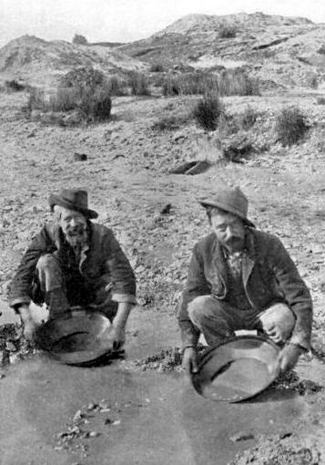
Early in June of 1854 a few soldiers and a Government man came to Rocky Creek to tally the workers in the field. 'Just a little too much like counting sheep,' Mum declared when I told her. I remember it well for Dad and I had returned from the diggings to our home in Skeleton Creek just down the Grafton track from Glen Innes. Seli, as mothers are wont to do was keen to celebrate our return with the second birthday of my youngest brother Paddy. Homecomings mark milestones in my memories, and this was a very warm and happy recollection. Our simple celebration with James then seven and Rosanna just four gathered our family in a warm glow of contentment. In later life, Paddy followed in Dad's footsteps as a town crier in Glen Innes. As 'Bell Man' he was noted for being the 'most original of all town criers ... his means of advertising was certainly unique'.
My birth and that of my siblings including Paddy were never officially recorded. I found out that the 'powers that be 'required no birth record to be kept of any newborn older than half a year. But only townsfolk and the wealthy were close enough to civilisation to be registered within the first six months of life. Dad made something of a fuss about the fact that, at last, I was recorded by officialdom. He said the census tallied 99 kids, 58 women and 193 men living in tents on the field. But most of the diggers found no fortune in the gravel sand and mud, at least not enough to fill their dreams. We too abandoned the diggings and Dad returned to his line of work as a sawyer.
Down on the coast fortunes were made in Red Gold but only by the dealers, middlemen who stamped their seal on lumber, already dressed and ready for shipping south to the colony and thence to the world. Cutters and sawyers lumbered on but only sniffed the bonanza provided to the dealers in the lucrative lumber game. Dad was able to provide adequately for our family, now domiciled on the New England plateau at Vegetable Creek. Many Chinese gardens provided fresh produce for local families as prospectors searched the hills and gullies for their pot of gold, be it gold or red gold. As a cedar cutting Sawyer, Dad was kept away from home months on end working down in the coastal forests east of the tableland. Mum and us kids were left behind to tend the slab hut we called home. Mum, resourceful as she was and ever looking for a way to supplement our income, had taken to selling grog on the sly. Only years later did the 'business' come under Government control. On the face of it, the subsequent sale of the license helped finance our families move into mining in the 70's.
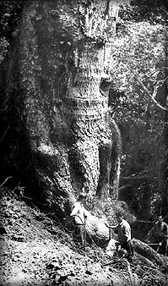
Life for us kids was a riot of fun and friendships in the bush along the creek. With two brothers and a sister, we formed a formidable mob ready to take on the world of our private town. Our youthful neighbourhood battles needed to be staged out of sight of the adults, but the scars with which we returned home gave us away. Nothing ever was really life threatening for most battles were purely for fun and involved, not sticks and stones but mostly just lots of posturing and name calling. Race was as good a reason as any for a donnybrook, and often we exchanged missiles in the morning with our oriental neighbour's kids and in the arvo we dug the garden together. My best friend outside the family was Ah Yee with whom I used to wrestle and explore, and for hours, we would discuss our dreams and plans. We did eventually work on the same diggings in the 80's. However, my childhood came to an end in the bitter cold of August 1856, as I turned 14, for Dad declared I was 'big enough n ugly enough' to be getting to work.
With growing pride in my approaching manhood, Dad and I rode out together through Glen Innes towards Grafton to work in the logging camps East of the Land of the Beardies. Winter was the coolest time to fell timber in the tropical rainforests along the coast. But it was also the wildest weather around our home at Vegetable Creek. Winter in the Highlands meant weeks of howling winds, and icy gales fit to freeze even a Billy of drinking water left out overnight. I felt sadness at leaving Mum and the family behind, but I was excited at the prospect of my move towards manhood.

Felling a red cedar: Newcastle Museum Collection

Story Copyright © T Quinn

Wikipedia, Illawarra Cedar Forests, http://en.wikipedia.org/wiki/Illawarra
Wikipedia, First Government House, http://en.wikipedia.org/wiki/Old_Government_House,_Parramatta
Wikipedia, Early settlement north of \syney Town, http://en.wikipedia.org/wiki/Hawkesbury_River
Raymond, James. (1966). The N S W calendar & G P O directory, 1832 http://nla.gov.au/nla.cat-vn2181891
Early Routes by J Raymond 2010 http://freepages.genealogy.rootsweb.ancestry.com/~jray/grace/roads.htm#4a
Op. Cit. Hodgkinson, Clement. (1845). p 31 http://nla.gov.au/nla.cat-vn740742
ABC RN Hindsight Sunday 24 July 2011 http://www.abc.net.au/radionational/programs/hindsight/in-search-of-red-gold-the-story-of-red-cedar/2953996
Wikipedia, Tasman Sea, http://en.wikipedia.org/wiki/Tasman_Sea
Op. Cit. Raymond J, Early Routes 2010 http://freepages.genealogy.rootsweb.ancestry.com/~jray/grace/roads.htm#4a
Rogers F, Edwards R, Hastings DHS (1982) Pt Macquarie hist. to 1850. p 142-5 http://nla.gov.au/nla.cat-vn105039
Grafton Road http://www.environment.nsw.gov.au/NationalParks/parkHeritage.aspx?id=N0569
Wikipedia, Uralla, http://en.wikipedia.org/wiki/Uralla,_New_South_Wales
Wikipedia, Rocky River, http://en.wikipedia.org/wiki/Rocky_River,_New_South_Wales
Patrick (Paddy) Quinn Obituary. Glen Innes Examiner.Tuesday September 22, 1908
NSW BDM regulations then in place http://www.bdm.nsw.gov.au/Pages/about-us/history-of-the-registry.aspx
Wikipedia, Census 1854, http://en.wikipedia.org/wiki/Rocky_River,_New_South_Wales
DME VIC Fossickers in Nerrena Ck Vic http://trove.nla.gov.au/work/19259944?selectedversion=NBD3934745
Authors note: Patrick Quinn involvement in the Cedar industry is inferred from his recorded occupation as a sawyer.
A giant red cedar tree 1944.: Newcastle Regional Museum Collection In SMH of May 17 2004, http://www.smh.com.au/articles/2004/05/16/1084646068464.html
Story Copyright © T Quinn. All rights reserved.

